1. Create repository in github site
2. Clone that repository in eclipse

File > Import > Git > Projects from Git > Clone URI

.

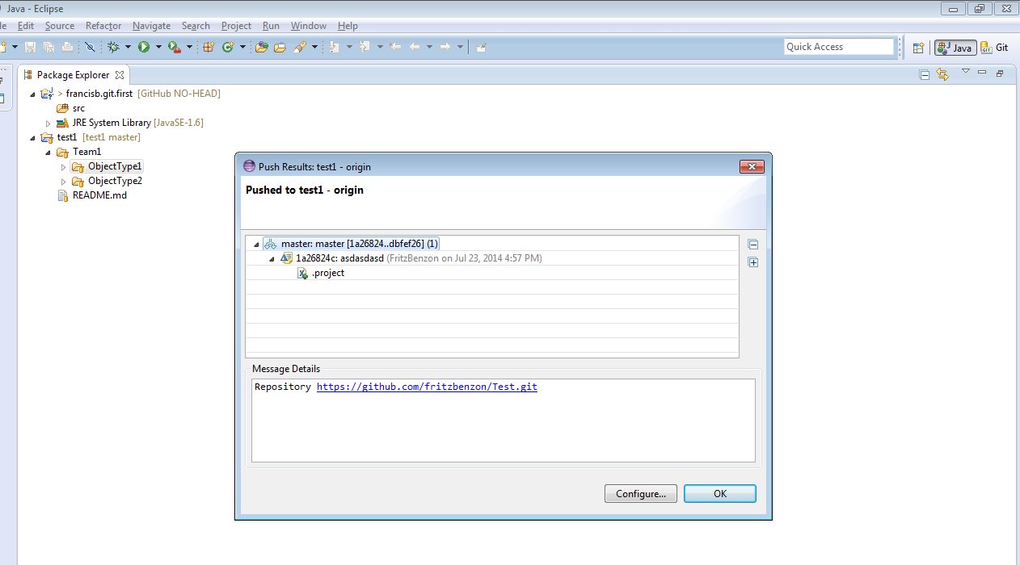

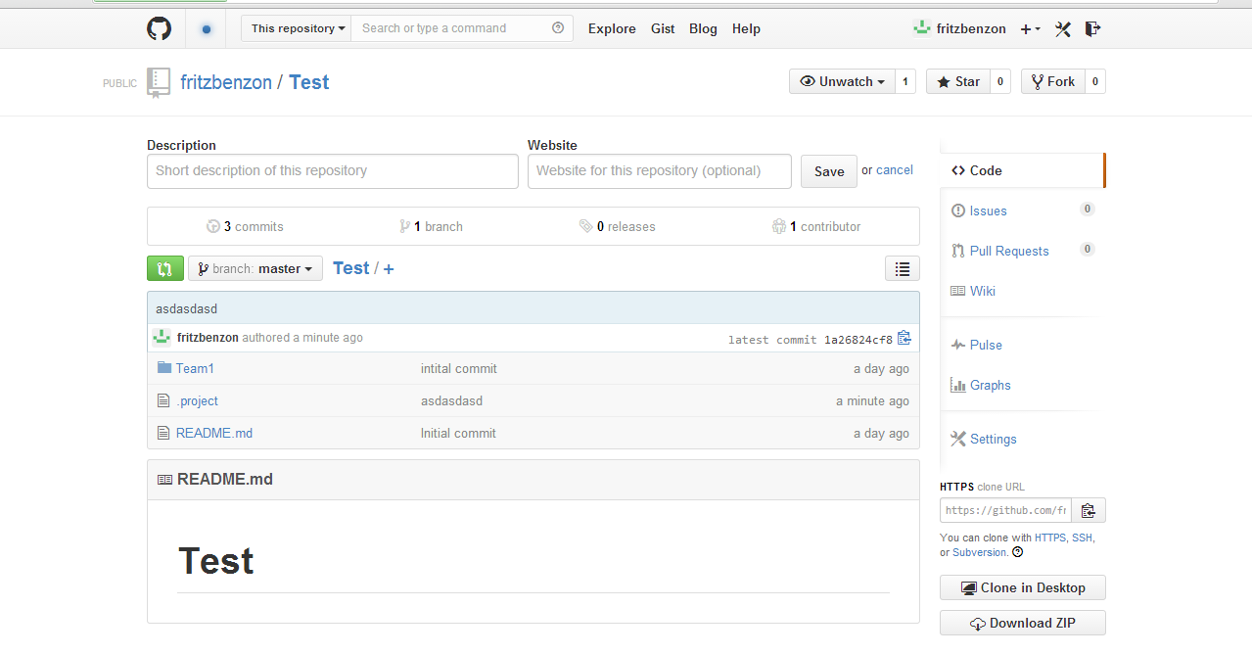

|  |  |
| --- | --- |
| Email to Case | Email to Case Setup |
| Queue | Email to Case Queue |
| Assignment Rule | Email to Case Assignment rule |
| List View | Email to Case List View |
| Workflow | Case Queue Email Notification |
| Email Template | Case Queue Email Notification |

